
Safe work method statement (SWMS): Excavation
Note: Work must be performed in accordance with this SWMS. This SWMS must be kept accessible for each relevant worker and available for inspection until the high risk construction work related to this SWMS is completed. If the SWMS is revised, every version should be kept. If a notifiable incident occurs in relation to the high risk construction work in this SWMS, the SWMS must be kept for at least 2 years from the date of the notifiable incident.
Company name: |  | Principal contractor (PC):
Work activity: | Small-scale excavation and air spading related to tree works | Date SWMS provided to PC:
Works manager: |  | Workplace location:

High risk construction work:
☒ Risk of a person falling more than 2 metres | ☐ Work on a telecommunication tower
☐ Demolition of load-bearing structure | ☐ Likely to involve disturbing asbestos
☐ Work in or near a confined space | ☐ Temporary load-bearing support for structural alterations or repairs
☐ Use of explosives | ☒ Work in or near a shaft or trench deeper than 1.5 m or a tunnel
☒ Work on or near pressurised gas mains or piping | ☐ Work on or near chemical, fuel or refrigerant lines
☒ Work on or near energised electrical installations or services | ☐ Work in an area that may have a contaminated or flammable atmosphere
☐ Tilt-up or precast concrete elements | ☒ Work on, in or adjacent to a road, railway, shipping lane or other traffic corridor in use by traffic other than pedestrians
☒ Work in an area with movement of powered mobile plant | ☐ Work in areas with artificial extremes of temperature
☐ Diving work | ☐ Work in or near water or other liquid that involves a risk of drowning

Person responsible for ensuring compliance with SWMS: | Example: Supervisor / Crew Leader | What measures are in place to ensure compliance with SWMS? | Examples:  DELETE THIS BOX ONCE READ:  These ArbSafe Pack resources are templates only. They must be customised for your workplace ensuring that:  - Relevant legal requirements have been met,  - Workplace / task specific risks are identified and managed, and  - Workers are consulted with during the customisation / review process.  JHA before starting work  On site supervision  Regular spot checks and site inspections
How will SWMS control measures be reviewed? | Example: Control measures will be reviewed by the Site Supervisor / Crew Leader (in consultation with workers):  At the start of each shift during the JHA | If there is a change in the scope of work or work conditions | After any incident or near miss (as required) | At the request of an HSR or worker | If the current controls are found to be ineffective
Approver/s: |  | Signature: |  | Approval Date:

What are the tasks involved? | What are the hazards and risks? | What are the control measures?
List the work tasks in a logical order. | Identify the hazards and risks that may cause harm to workers or the public. | Describe what will be done to control the risk. What will you do to make the activity as safe as possible?
Pre-start and planning | Unidentified hazards, lack of communication | - Conduct pre-start briefing; review Dial Before You Dig (DBYD) info; confirm permits and exclusion zones.  - Conduct a general site background check to determine if there are likely to be any contaminated soils
Working near trees | Falling branches, tree instability | - Assess tree stability before work  - Avoid under canopy where risk of failure exists  - Maintain communication with arborist if required
Service location | Striking gas, electrical, water, telecom, fuel, or other underground utility | - Use current BYDA / service plans  - Site walkover / visual inspection to look for signs of services  - Use electronic location (cable wand / GPR) to assist where required  - Mark out services  - Use non-destructive digging (NDD) when excavating near known utilities  - Spotter / Safety Observer in place when excavating near utilities  - Maintain minimum approach distances
Use of air / water lance  (high pressure water jetting or air spading) | High pressure water or air blast; soil blowback – injury or utility damage | - Trained and competent operator  - Exclusion zone established and maintained  - Fit wand with oscillating nozzle  - Appropriate air pressure and distance from roots  - Direct lance away from body and others  - Fit shields where necessary  - Use proper technique:  - Maintain a minimum distance of 400mm between the end of pressure jet nozzle and the subsoil or underground utility  - Keep the jet moving  - DO NOT aim at people or directly at underground utilities  - Stoe work if roots or utilities are damaged  - Operator PPE: face shield and safety glasses, gloves, and hearing protection, safety boots
 | Asbestos Pipes | - Do not directly aim the jet at asbestos pipes or use to clean them  - Confirm conduits / pipes are free from asbestos or treat them as if they contain asbestos
Use of plant/equipment to excavate | Contact with persons or property | - Competent and ticketed operator only  - Establish and maintain exclusion zone  - Use barricades, signage, spotter; hi-vis clothing  - Follow traffic management plan  - follow plant SWMS if applicable.
Use of plant/equipment to excavate | Plant overturning | - Ground is stable. If required, support plant with stabilisers or use blocks or pads  - Position spoil, plant and other loads outside the zone of influence - usually 45 degrees out from the bottom of an excavation and at least 600mm  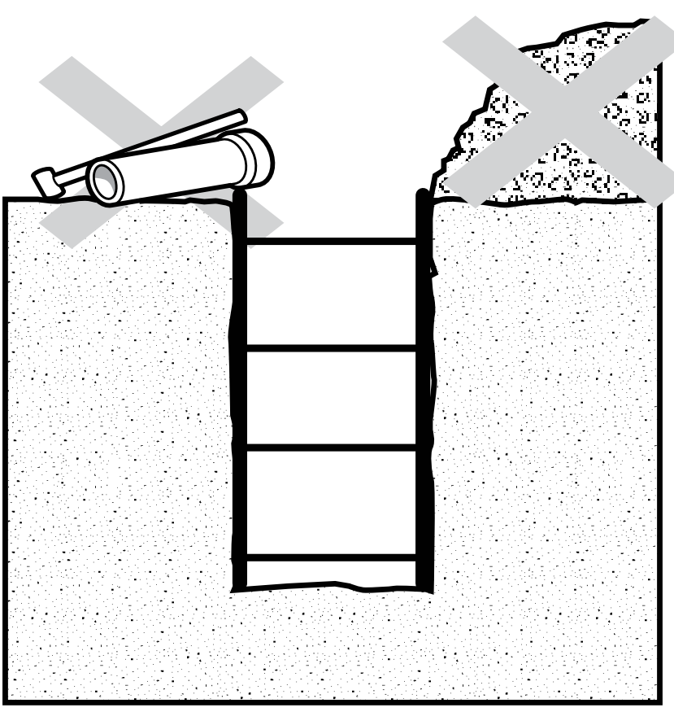  Excavated material and tools too close to the edge of the trench  - Plant Operator/s are licensed / competent for specific type of plant, and the plant is fit for purpose  - Communication between plant operator and Spotter / Safety Observer established prior to works commencing. The Spotter / Safety Observer to always be in view of the operator
Use of plant/equipment to excavate | Open excavation – falls risk | - Barricading to be installed around / along trenches if necessary  - Do not leave any excavation or open hole unattended or unsecured  - Workers other than the spotter are to stand clear of trench.  - Workers to avoid entry to excavations / trenches wherever possible; If entry is required, provide safe means of access / egress for excavations deeper than 1m (ladders, stairways, ramps)
Use of plant/equipment to excavate | Noise | - Use hearing protection  - Limit exposure duration
Use of plant/equipment to excavate | Dust / debris | - Enclosed excavator cabin  - Cover truck / trailer load when removing spoil  - Where possible keep distance from excavation operations  - Wet down spoil with water and wear P2 dust mask if required
Soil collapse / trenching (>1.5 m) | Burial, entrapment | - This SWMS is for shallow works only (<1.5 m). If deeper excavation required – separate SWMS and shoring/benching/battering plan to be developed.

Sign on Sheet (review and acknowledgement)
Name | Signature | Date |  | Name | Signature | Date

Additional Information

